# Assignment 2 – Group Work – Student Individual Reflective Report

|  |  |
| --- | --- |
| Student ID: | 1915677 |
| Student Name: | Niraj Chudali |
| Group No: | 07 |

This confidential Individual Reflective Report (one from each student) should be submitted using the appropriate link on BREO by every member of your group and will be used to assess your contribution to the group work, the level of teamwork in your group and the contribution of individuals.

The report should reflect on the ease or difficulties that you encountered when completing this group assignment. It should include how you worked with the others in the group to produce the final report and program, the difficulties you encountered and how these problems were overcome, your evaluation of your own contribution to the group work as well as the contribution of others in the group, what you have learned from doing this group work, and how would you do things differently in the future.

In addition, you should list your group members in the grid below and next to the details of each group member please use the one letter code below to indicate your perception of their contribution to the project work submitted by the group. Their contribution includes work on the group co-ordination, coding, testing, report writing or any other activity that led to successful submission. Please choose the code that appropriately describes your peers’ input:

S - Significant (The group member’s work was integral to the overall submission)

N - No Contribution (The group member took no part in the project submission)

I - Insignificant (The group member’s work made little difference to the overall submission)

|  |  |  |  |
| --- | --- | --- | --- |
| Student Number | Last Name | First Name | Contribution (N,S,I) |
| 1915684 | Bist | Roshan | S |

Continued….

# Your Individual Reflective Report

It has been a wonderful experience working for the very first time in java. People use to tell java is a quite complicated but I enjoyed a lot working on it. I used to work in python but never worked in java but this assignment teach me lots of things. I get to know the concepts like object oriented, multithreading and many more.

Working in a team has been always interesting. Get to know each other and can share information a lot. The same thing happens for this project also. As a main developer working in this project I get more confidence to work with programming language and added one more skill in my portfolio.

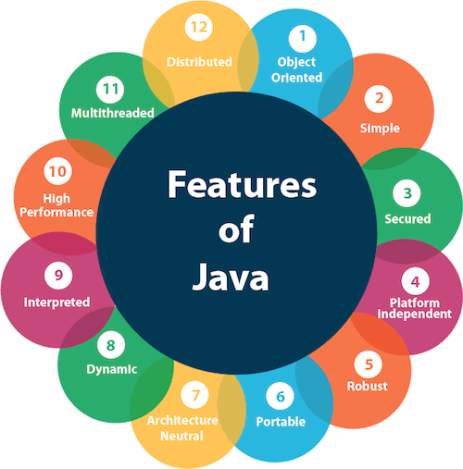

Fig:Features of Java

source(<https://www.javatpoint.com/features-of-java>)

Now I get the answer to the question “why java is so popular?”.

So, it was fun working with java and playing with object oriented programming concept. According to the project assigned by the University of Bedfordshire in Principle of Programming module I did following work as mentioned in the work division. I worked as a main developer during the whole software development process.

1. Login

Login page includes the Student Name and Student Id. Before login to the system user have to first register into the system. Student name and the student id both are variable characters and must be equals to or more than five characters long. If the user exists in the system then by pressing the login button he/she can access our system dashboard. If the user press cancel button the user get exit from the system. If the user account doesnot exists he/she can go into new user label where they can get access to the registration page.

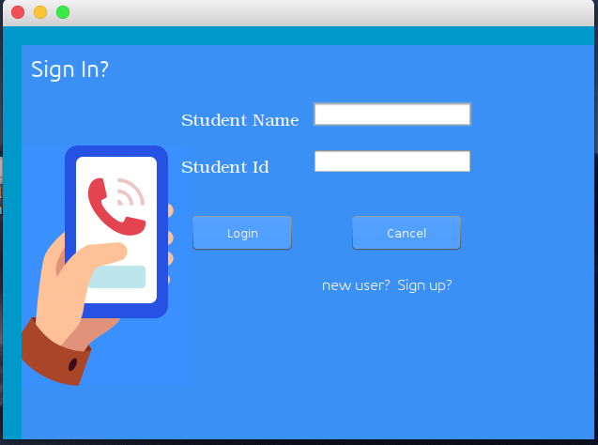

2. Registration

Registration page consists of id, fullname, gender and their interests. Id and full name are the variable characters where gender is a radio item and interest is a multiple selecting check buttons. Interest is the extra freature included in the system thing about to expand this project more and use machine learning to recommend the appropriate events according to the user interest.

The id and full name must be more than or equals to five character long. In which id must be unique. When the user fulfills the system requirements he/she will redirected to the login page from where they can login and access our main dashboard.

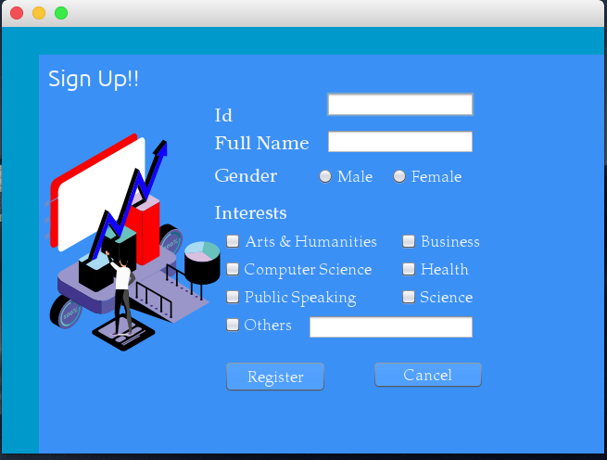

3. Home Page

Home page is the main page of our system. The main dashboard consists of different events like academic, technology, Leadership, Entertainment, Sports , Culture and Language. Students can search the different events. In the top right corner we have red icon which is the logout button. The middle one is the student profile and the first one is the new features which gives the information about the current pandemic corona virus. In the bottom left there is an explore button. Using this users can easily explore the different events posted in the system. And in the bottom right there is a my booking tab where users can see the events that they have booked.

Every items in this home page are connect with the mysql database expect corona information center. When the user click any of the items then the data is extracted from the database and the user can get every posted events.

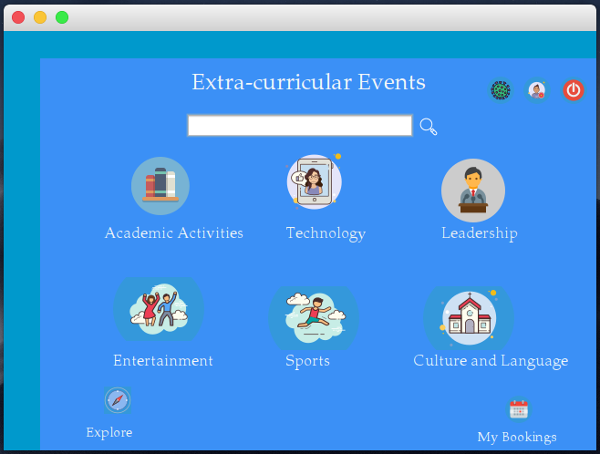

4. User Profile

Like every system we have also this user profile section where user can get the details stored about him/her in the system database. The login information is extracted from the database and displayed in the profile section.

The details in the below screenshot is mine.

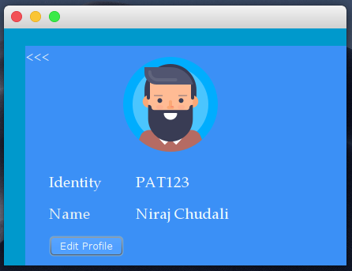

5. Explore

I have mentioned this in the presentation also that the inspiration for the explore freature is instagram. As like instagram I have designed this page a same way. I extracted all the posted events from the database and displayed in a column format in a single page.

There is a slider in the right side of the screen through which the user can go down to the page to see all the posted events. There is also a “go to post home” button through which user can easily go to the respective post home and can register from there.

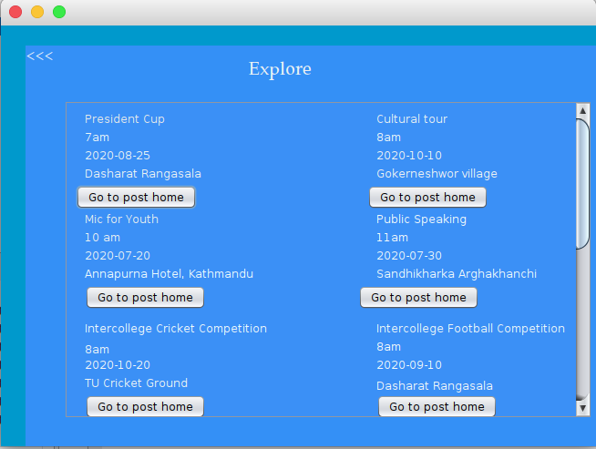

6. Corona Virus Information Center

Although I don’t use social media a lot but the idea behind this is also from the instagram parent company Facebook. There is also an information system which I like the most because it can aware lots of people about corona viruse. So, I also get inspired and developed this page as an information center for covid-19.

This page gives some basic knowledge abour corona viruse,causes, its effects and many more.

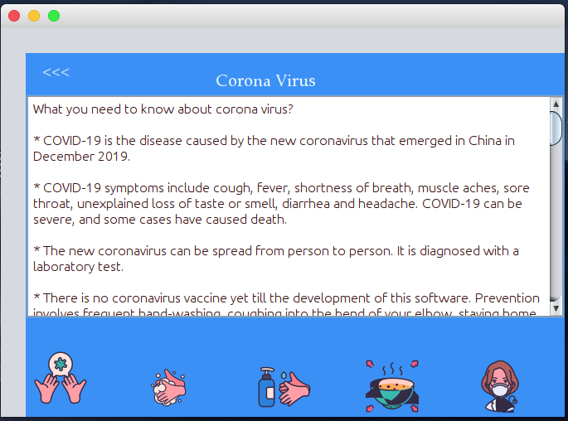

7.Book Event

Every panels have different events according to their category. So the events have following details:

* Event Name
* Event Time
* Event Date
* Event Venue
* Type of Event(optional)

So the user can book the events that are available. If the user succefully booked the event the event details will be visible in the my booking page of the home page. If the user cancel the after clicking book button the event will exist in the same page.

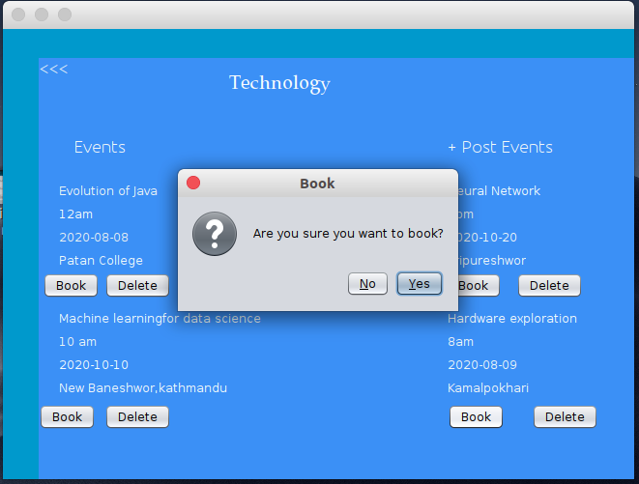

8. Database Connections

As per the requirement of the university I have used the mysql database to store the data. User information and events details are stored in the database in the tabular form.

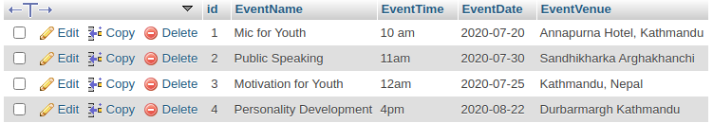

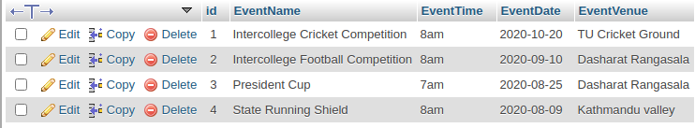

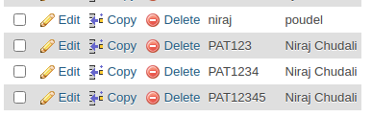

After a hard work and research we are able to develop a fully functioning software named Event0. As a beginner in the field of software it wouldn’t have been completed single handedly. We both of us give our best so that we are able to complete our project in time. I would also like to thank Ganesh Dixit sir to coordinate us in every obstacles we faced during the whole software development process. I feel proud and motivated myself after completing this project. I learn lots of thing from this project like how strong is java, how the fully functioning software can be written from java, why java is so popular and many more. Moreover I think it will motivate me to do such type of project more in near future.

Some Code Snippets

